Practical No. 24
Aim : WAP to implement :
1. Single inheritance 2. Multiple inheritance 3. Multilevel inheritance

Name : Danish Altaf Solkar | Class : CO - B
Enrolment no. : 24111590805 | Batch : 2

2) WAP to read and print students information using single inheritance.

Code :-

class Student:
def getData(self):
self.name = input("Enter student name: ")
self.roll = int(input("Enter roll number: "))
class Result(Student):
def display(self):
print("\nStudent Information")
print("Name:", self.name)
print("Roll Number:", self.roll)
s = Result()
s.getData()
s.display()

OUTPUT :-
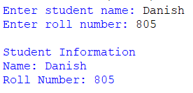

3) WAP to implement multiple inheritance.

Code :-

class Student:
def getData(self):
self.name = input("Enter name: ")
class Result(Student):
def display(self):
print("Student Name:", self.name)
s = Result()
s.getData()
s.display()

OUTPUT :-
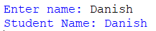

4) WAP to implement multilevel inheritance.

Code :-
class Student:
def getName(self):
self.name = input("Enter name: ")
class Marks(Student):
def getMarks(self):
self.marks = int(input("Enter marks: "))
class Result(Marks):
def display(self):
print("Name:", self.name)
print("Marks:", self.marks)
r = Result()
r.getName()
r.getMarks()
r.display()

OUTPUT :-
